



**DEPARTMENT OF COMPUTER SCIENCE**

**AND APPLICATIONS**

**IBM PROJECT REPORT**

**REAL-TIME ENVIRONMENTAL**

*Submitted by*

GOKUL PRASATH.S

SUDARSHAN.S

LOKESHWARAN.G

**BACHELOR OF SCIENCE IN COMPUTER**

**SCIENCE WITH ARTIFICIAL INTELLIGENCE**

*Under the guidance of*

*Aiswarya Vijayan - Corporate Trainer*

**2023 - 2024**

**DECLARATION**

We,  **LOKESHWARAN.G, GOKULPRASATH.S and SUDARSHAN.S(222312117) . A**hereby declare that this project report on **“**Analysing Real-time Environmental system data using COGNOS tool” submitted to University of Madras in partial fulfilment of the requirement for the award of the Degree Bachelor of computer science with Artificial Intelligence under the guidance of **DR.G.MONIKA M.Sc., PhD., HEAD OF DEPARTMENT** and **SUBHA SRI. S** has not been submitted earlier to any other university or institute for the award of any degree.

GOKUL PRASATH.S

SUDARSHAN.S

LOKESHWARAN.G

**Place:**

**Date:**

**BONAFIDE CERTIFICATE**

This is to certify that the project titled “Analysing Real-time Environmental system data using COGNOS tool”is the bonafide work done by **, LOKESHWARAN.G, GOKULPRASATH.S and SUDARSHAN.S. A**hereby and first year student of Jeppiaar College of Arts and Science , Padur, Chennai in partial fulfilment of the requirment for the award of the Degree of Bachelor of computer Science with Artificial Intelligence 2023-2024.

**PROJECT GUIDE: SUBHA SRI. S**

**HEAD OF THE DEPARTMENT:**

**Date:**

|  |  |  |
| --- | --- | --- |
| **S. No** | **INDEX** | **Page No** |
| 1. | INTRODUCTION |  |
| 2. | ABSTRACT |  |
| 3. | REPORTS   1. WATER POLLUTION, AIR QUALITY, CLIMATE PATTERNS AS LIST 2. WATER POLLUTION IN INDIA 3. AIR QUALITY IN INDIA 4. CLIMATE PATTERNS IN INDIA 5. OVERALL MONTH |  |
| 4. | FINNAL DASH BOARD |  |
| 5. | CONCLUTION |  |
| 6. | REFERENCE |  |

**INTRODUCTION:**

Our project focuses on leveraging IBM COGNOS Analytics for analyzing Real-time Environmental data. With COGNOS' versatile toolbox including List, Text Item, Block, Table, Crosstab, and Visualization features, we delve into data exploration and analysis. By uncovering trends and patterns, we aim to the fundamentals of environmental monitoring based on air quality, water pollution, and climate patterns in India. Join us as we utilize COGNOS to extract actionable insights and drive informed decision-making in Real-time Environmental.

Top of Form

Top of Form

**ABSTRACT:**

This project focuses on harnessing the power of sensor data from environmental monitoring devices to enable real-time tracking and analysis of critical environmental factors. By leveraging advanced analytics and BI capabilities, the project aims to monitor and manage air quality, water pollution, and climate patterns in a proactive and efficient manner. The project will provide decision-makers with valuable insights and actionable information to make informed environmental management decisions, promote sustainability, and safeguard the well-being of communities and ecosystems.

Top of Form

**REPORTS:**

Top of Form

Water pollution

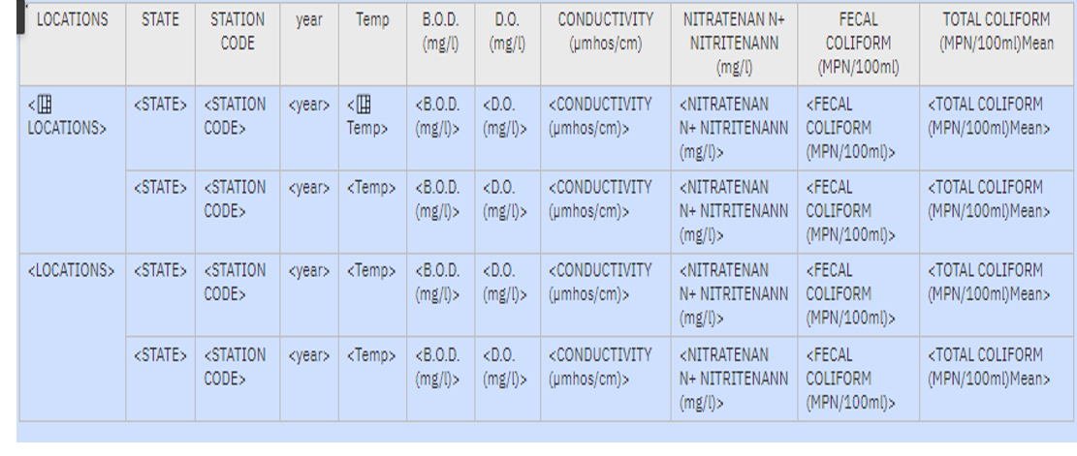

**OUTPUT:**

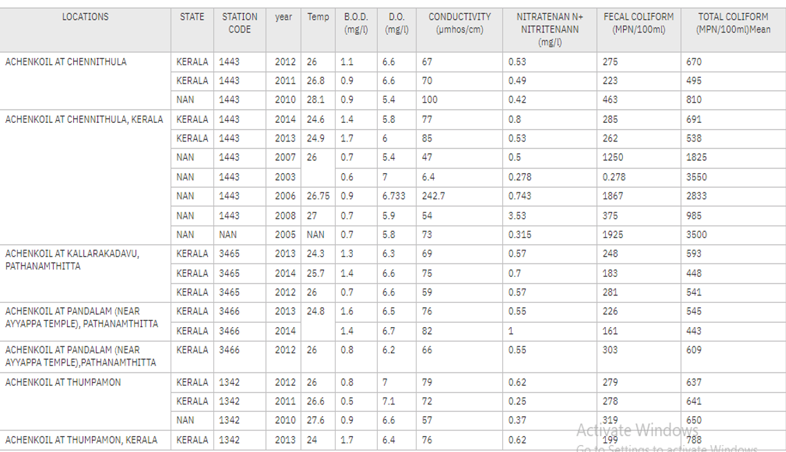

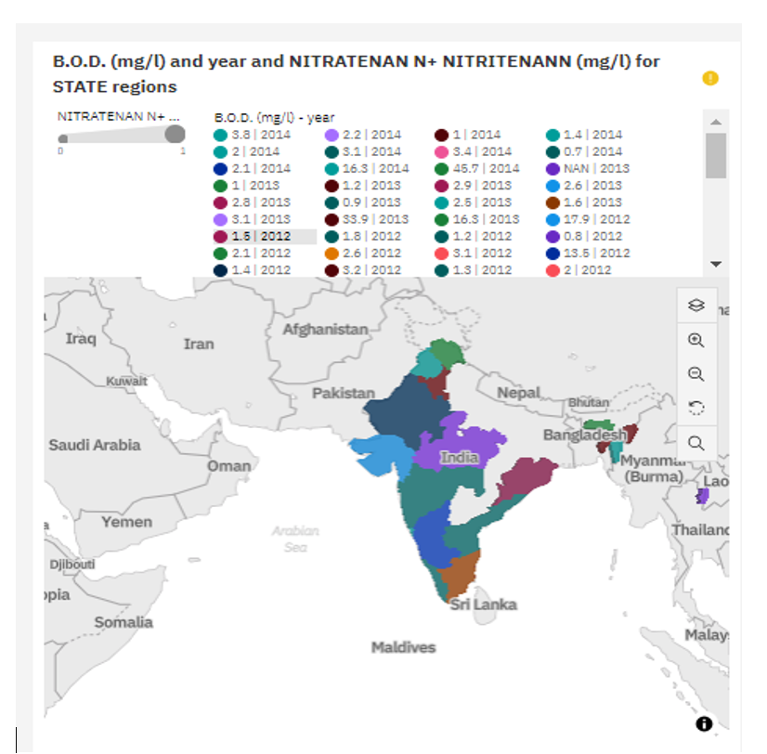

Air quality

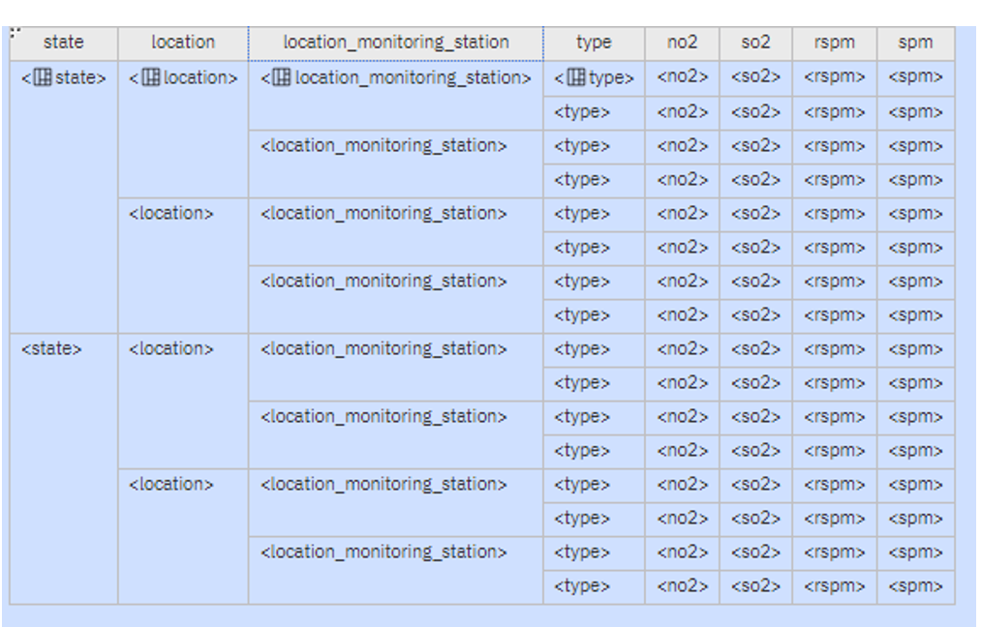

**OUTPUT:**

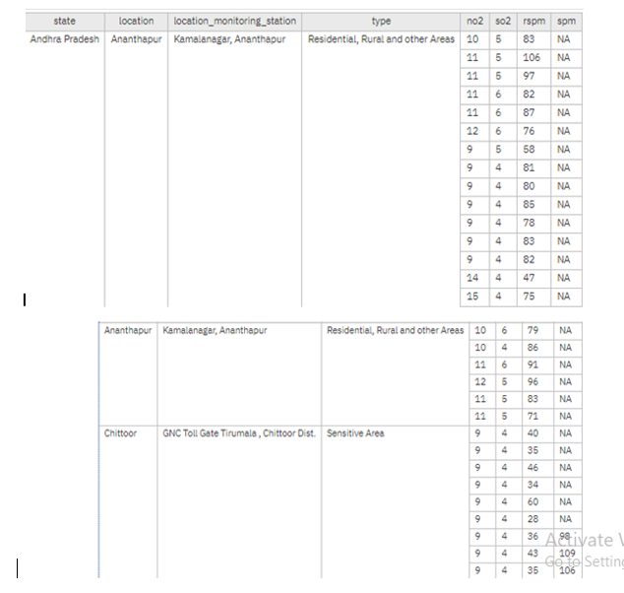

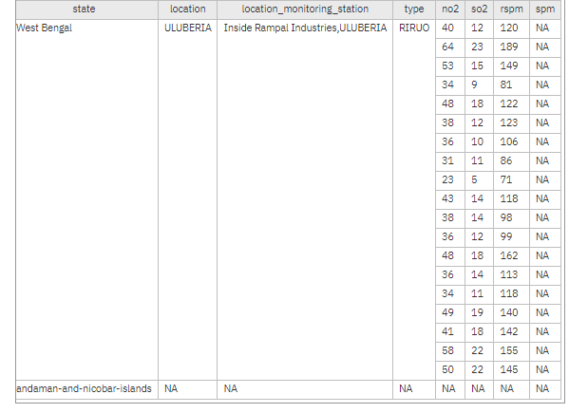

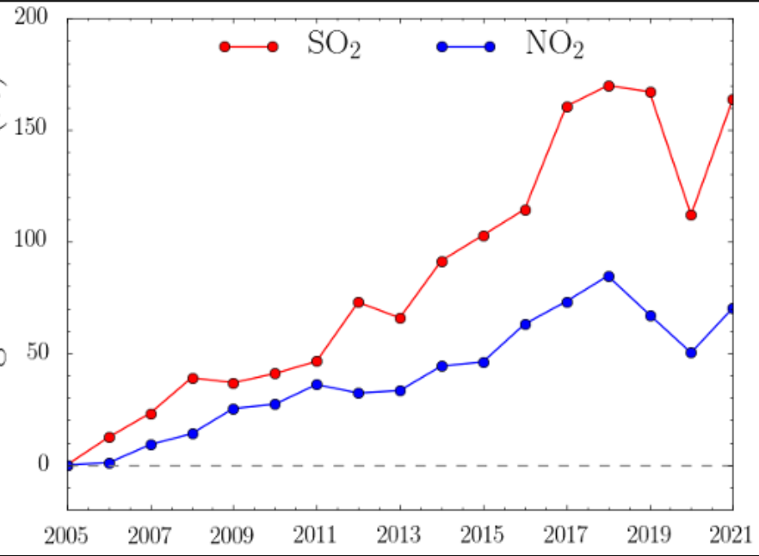

**SO2 –**Sulphur dioxide

**NO2 -**Nitrogen dioxide

Climate patterns

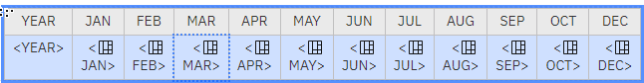

**OUTPUT:**

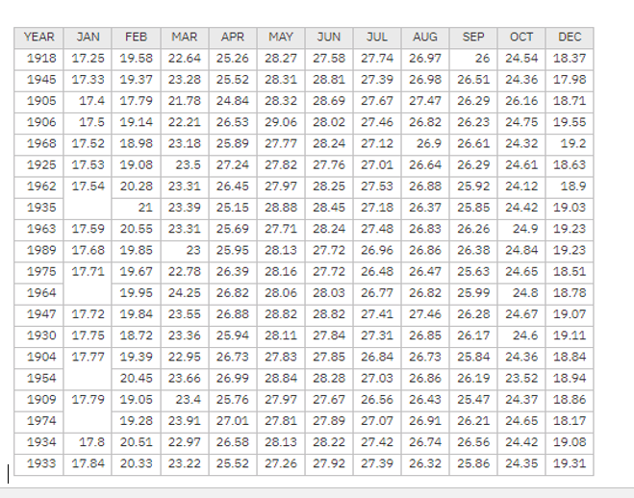

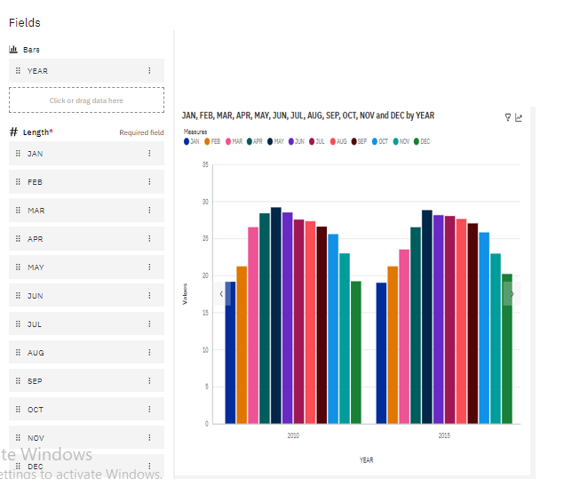

**FINAL DASH BOARD OF REAL-TIME ENVIRONMENTAL:**

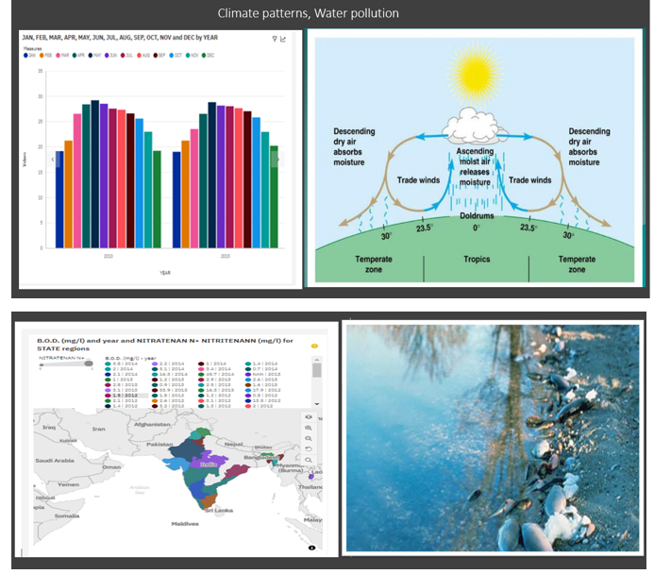

**CONCLUSION:**

Our project has used IBM COGNOS Analytics to study environmental data better. We've explored different parts of the data using tools like lists, tables, and visualizations. By doing this, we found trends and patterns that help environmental. This shows how important it is to use data to make smart decisions in the environmental industry.

**REFERENCE**:

<https://us1.ca.analytics.ibm.com/bi/?perspective=home>

[https://www.kaggle.com/datasets/jessemostipak/environmental-booking-demand](https://www.kaggle.com/datasets/jessemostipak/hotel-booking-demand)